**Market Research On Frugl app**

# What is Frugl?

The Frugl app aims to revolutionizes the shopping experience for Australian by empowering users to compare products and prices between Woolworths and Coles supermarkets. Through this comparison, users can customize their shopping lists for each store, ensuring a tailored experience to their preferences. Frugl gathers product and pricing data from multiple retailers before further organizing and enriching it via automated processing and Machine Learning. The data is made available to shoppers via the Frugl Grocery mobile comparison and wellness app, with app usage generating additional retail intelligence in the form of behavioral and shopper segment data.

# Key Features of Frugl:

* **Price comparison:** Frugl utilizes cutting-edge technology to compare prices across various retailers within users' local areas.
* **Wellness Tools Integration:** In addition to price comparison, the new Frugl app incorporates wellness tools. These tools enable shoppers to evaluate products based on nutritional value, ingredient listings, allergen inclusions, health ratings, and sustainability factors, facilitating optimized shopping baskets.
* **Provide recipe page for different healthy foods:** Frugl provides a dedicated recipe page for a diverse range of delicious meal options. Users can explore a wide range of recipes tailored to various dietary preferences, including vegetarian, vegan, gluten-free, and more.
* **Grocery Pricing & Promotion Analytics Platform:** Frugl introduces its Grocery Pricing & Promotion Analytics platform, leveraging data collected since May 2019.
* **Data Analytic platform for retailors:** Frugl confirms its venture into commercializing data analytics products. By engaging in discussions with major Australian retailers and grocer suppliers, Frugl aims to align with their data analytics objectives and offer tailored analytics solutions to meet their needs.

# Advantages of Frugl:

* Save money on every shopping: Discover savings on thousands of products each week from grocery retailers across Australia, helping you stretch your budget further.
* Customize and refine search results based on dietary needs and allergens: Tailor your shopping experience by setting dietary preferences or highlighting allergens, ensuring that products align with your specific requirements.
* Effortlessly find what you need: With the ability to search through over 50,000 available products or simply scan the barcode, locating items has never been easier.
* Scan product barcodes on the go: Streamline your shopping experience by scanning product barcodes directly from your mobile device, instantly accessing pricing and comparison information.
* Earn Rewards with every purchase: Accumulate Honey Gold points with each purchase, unlocking additional savings opportunities for future shopping trips.
* Save time with built-in comparison tools: Simplify the process of comparing prices across multiple sites with our integrated comparison tool, minimizing the time and effort required for smart shopping.
* Seamlessly integrate wellness tools: In addition to price comparison, the Frugl app integrates wellness tools to help users make informed choices about their purchases. Evaluate products based on nutritional value, ingredient listings, allergen information, health ratings, and sustainability factors, ensuring your shopping basket aligns with your health and wellness goals.
* Explore a variety of healthy recipes: Dive into our dedicated recipe page featuring a diverse selection of nutritious meal options. Whether you're vegetarian, vegan, gluten-free, or have other dietary preferences, discover delicious recipes tailored to suit your lifestyle.

# How Frugl Stands Out Against Competitors:

Frugl sets itself apart from competitors through a range of distinctive features:

* + **Enhanced List Management:** Introducing new List features such as Favorites and Custom lists, allowing users to curate their shopping experience with ease. Additionally, Frugl enables the import of saved lists from external sources, such as recipe ingredient lists, streamlining the shopping process further.
  + **Collaborative and Household Lists:** Facilitating seamless collaboration among multiple users within households, Frugl's Household lists feature ensures that everyone can contribute to and benefit from shared shopping lists, fostering greater convenience and coordination.
  + **Advanced Filtering Options:** Frugl empowers users to refine their search results based on dietary preferences and allergies, providing a personalized shopping experience tailored to individual needs and ensuring peace of mind while browsing for products.
  + **Barcode Scanning Capabilities:** With Frugl's intuitive barcode scan functionality, users can effortlessly obtain detailed product information and pricing, enabling quick and informed purchasing decisions while on the go.
  + **Comprehensive Analytics for Retailers:** Frugl goes beyond consumer-facing features by offering valuable analytics tools tailored for large supermarkets and retailers. These analytics provide insights into shopper behavior, preferences, and trends, empowering retailers to optimize their offerings and enhance the shopping experience for their customers.

# Potential Weaknesses:

* **Limited Retail Coverage:** Frugl's current limitation lies in its exclusive coverage of Coles and Woolworths supermarkets
* **Lack of Receipt Imaging Functionality:** One notable weakness of Frugl is its absence of a feature allowing users to capture and store images of their receipts. This functionality could be invaluable for users who wish to track their spending, monitor purchases, or participate in cashback programs.
* **Limited Platform Accessibility:** Frugl's availability solely as a mobile app represents a potential weakness for users who prefer to access such services through web browsers or desktop platforms.

# Target Audience:

* + **Bargain Hunters:** Catering to savvy shoppers who are always on the lookout for the best deals and take pride in maximizing their savings on every online purchase.
  + **Insight for Supermarkets and Retailers:** Providing valuable insights into shopper behavior for large supermarkets and retailers, empowering them to understand their customers better and tailor their offerings to meet evolving needs and preferences.

# User Interface (UI) and User Experience (UX):

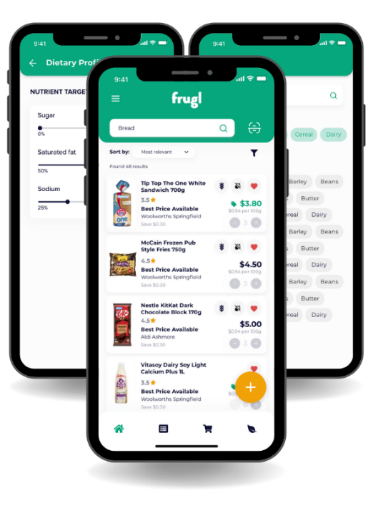

# Data Collection

According to data privacy of Frugl, here are the data that Honey collected during usage.

* **Personal Data:** Email address
* **Usage Data:** Usage Data may include information such as Your Device’s Internet Protocol address (e.g. IP address), browser type, browser version, the pages of our Service that You visit, the time and date of Your visit, the time spent on those pages, unique device identifiers and other diagnostic data.
* **Information from Third-Party Social Media Services:** The Company allows You to create an account and log in to use the Service through the following Third-party Social Media Services: Google, Facebook, Twitter. If You decide to register through or otherwise grant us access to a Third-Party Social Media Service, we may collect Personal data that is already associated with Your Third-Party Social Media Service’s account, such as your name, your email address, Your activities or Your contact list associated with that account.
* **Information Collected while Using the Application:** While using Our Application, in order to provide features of Our Application, we may collect, with Your prior permission: Information regarding your location, Pictures and other information from your Device’s camera and photo library.